<https://www.patriotgolf.us/custom-fitting/fitting-charts/>

It is important to know your height and your wrist-to-floor measurement.

To determine your wrist-to-floor measurement wear normal shoes and stand on a hard surface with your arms hanging relaxed at your sides. Then have someone measure from the point where your hand meets your wrist (your “wrist crease”) to the floor. With this measurement and your height, we will be able to determine the correct club length for you.

**Length of Club Chart based on height and wrist to floor:**

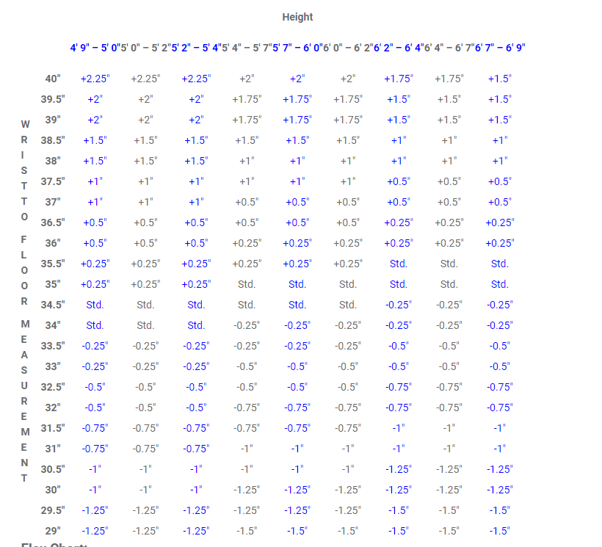

**Flex Chart and Standard Club Lengths:**

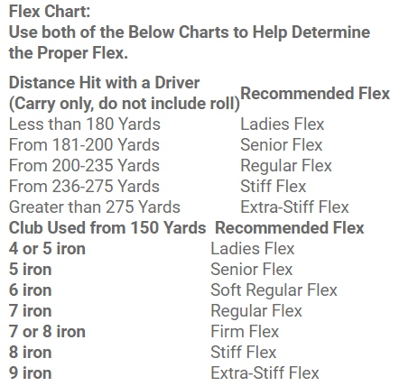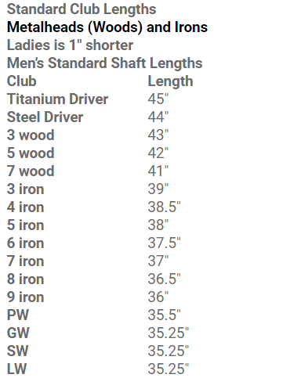

**Shaft Weight:**

We know that generally the more the shaft weighs the flatter the swing plane will be and the more inside out the swing path will be. Those golfers with lighter shafts will tend to swing more upright and tend towards swing outside the intended line of flight with their swing path. The closer we can get your swing path down the target line with the face of the club pointing at the target the more successful you are going to be at hitting straight shots.

We know also that head weight influences face angle in a similar way and if we can balance the head weight properly with the shaft weight we can achieve a square face at impact and create straight golf shots.